**MIS611 - Information Systems Capstone**

**(Assessment 2)**

**Solution Prototype Document**

Reinventing Money 2050

Country Name: Colombia

CDBC Name: AgroPay

|  |  |  |
| --- | --- | --- |
| Student Name | Student ID | Contribution % |
| Jessica Arango Castrillon | A00021154 | 33.3 |
| Ignacio Carreon Carrasco | A00045758 | 33.3 |
| Noman Tahir | A00033748 | 33.3 |

Lecturer: Elizabeth Mulhall

**2021 (Trimester 3)**

**Assessment 2 Content checklist**

|  |  |  |
| --- | --- | --- |
| **Number** | **Section to be completed** | Completed (please tick) |
| 1 | Introduction | X |
| 2 | Design Brief | X |
| 7 | Three Different Solution scenarios | X |
| 8 | Solution Prototyping | X |
| 9 | A solution Blue Print | X |
| 10 | Security Considerations | X |
| 11 | Ethical Considerations | X |
| 12 | Solution Evaluation | X |
| 13 | Conclusion | X |
| 14 | Appendix 1 – Research Data Collection strategy output | X |
| 15 | References according to APA 7th style | X |

**Signature of each group member confirming all group members have checked and completed all the assessment sections:**

**1.** Jessica Arango Castrillon

**2.** Ignacio Carreon Carrasco

**3.** Noman Tahir

**Table of Contents**

Table of Contents

1. Introduction 4

2. The Design Brief 5

2.1 The particular problems that are needed to be addressed: 5

2.2 The goals of the solution prototype: 5

2.3 The project management approach to be followed while designing the solution prototype: 6

2.4 Constraints: 7

2.5 Timelines: 8

2.6 Risks and mitigations: 9

3. Three different solution scenarios 10

3.1 Solution 1: 10

3.2 Solution 2: 11

3.3 Solution 3: 11

4. Solution Prototyping 12

5. A solution Blue Print 13

6. Security Considerations 14

7. Ethical Considerations 15

8. Solution Evaluation 16

9. Conclusion 17

10. Appendices 18

10.1 The data collection strategy 18

11. References according to the APA style 19

## Introduction

This paperwork is the development of a project based in the information collected in assessment 1. Assessment 1 has gave us a clear description of the problem, the target audience, SMART objectives, and requirements that were vital for informed brainstorming solutions that threw three different solution scenarios, and help us to take the most suitable solution to the problem in mention.

The reinventing money CDBC for 2050 that is developed in this paperwork is called , it is an augmented reality device that with the use of advanced technology, and services specifically designed for the agriculture industry use, will securely solve the problem at that time.

The Republic Bank is the current Colombia central bank. The Colombian government manages the Republic Bank of Colombia, and this is operated for private sector and government members. In addition, the community, government, investors, employees, suppliers and urban and rural farmers are the stakeholders, and the urban and rural farmers are the target audience identified for this project.

This paperwork is a solution prototype document that describes in section 2 the problems that need to be addressed, the solution goals, the used approach, timelines and risks. In section 3, the three different solution scenarios and described. Following, the solution prototype and blue print can be found in section 4 and 5 respectively. Finally, security and ethical consideration, and solution evaluation are explained in section 6, 7 and 8.

## The Design Brief

### 2.1 The particular problems that are needed to be addressed:

When it comes to discussing the problems that are needed to be addressed it can be said that it is evaluated that in Colombia, cash is probably going to disappear by the year 2050. However, the farmers of both the rural as well as the urban regions of the country are not totally prepared to get compatible with this drastic change (Sperling *et al.*2020). On the other hand, the International Monitory Fund demands the money to be reinvented in order to be handled effectively from the current time and therefore, it is essential to design a cashless solution for the sake of resolving the challenges of the farmers in Colombia. However, to do so it is essential to focus upon or address the new challenges that the farmers in the rural and urban areas are possibly going to come across (Gas, 2017). It is worth mentioning in this context that the farmers in the country end up playing the role of a potential building block in the economic system and hence helping them get accustomed to the new system through offering them the relevant services and products would be critical to holding the balance in the economic system of the country. In addition to that, the major problem that should be addressed is that cash would not be available to the farmers while they are going to offer the products, however, cash would not only be enough to meet their requirements. However, these issues in relation to going cashless can be resolved by taking the proper actions (Plano, Behrens and Zuidgeest, 2020).

### 2.2 The goals of the solution prototype:

To design a prototype in which monetary transactions taken place amongst the farmers should not be taken under consideration to provide the clients with a cashless alternative. This is a significant goal of the solution prototype since it is predicted that the physical transactions will almost disappear by the year 2050 whereas it may be used in certain areas where there is a lack of digitization and technical advancement. Therefore, this is going to complement the presentation of the existing financial services on a larger platform.

To take consideration into the requirements of the farmers should be taken account into as per the circumstances around them with conducting a detailed assessment of their personal profiles in order to develop services and products tailored to the farmers of both the rural and urban regions in Colombia. This is a significant goal of the solution prototype since the existing users have already been handling their digital monetary accounts efficiently and hence these services and products are going to help them in the process of getting compatible with the change.

### 2.3 The project management approach to be followed while designing the solution prototype:

#### Design thinking:

Design thinking refers to a design approach that would provide a solution-driven approach to resolve the problems. However, it is very effective while dealing with the complex issues that would be unknown or ill-defined through enabling an understanding of the human requirements involved, through re-designing or re-analysing the problem in a more human-centric manner, by creating a range of different ideas (Plano, Behrens & Zuidgeest, 2020). Therefore, in this project, the design thinking approach would be most suitable to resolve the incompatibility issue between the farmers and the cashless design (van Klyton, Tavera-Mesias and Castaño-Muñoz, 2021).

#### Double diamond:

The formal double diamond design approach includes four different stages of resolving a problem, which are discovery, development, definition and delivery. Additionally, combined, all of these four stages would function as a design map that the designers would be capable of using in order to organise their ideas, thoughts and concepts for the sake of adding value to the creative design procedure (Plano, Behrens & Zuidgeest, 2020). Apart from that, it is essential to take account into that this model of double diamond would not be linear in any way and hence would not possibly be appropriate in the context of the discussing solution prototype design. Then again, the creative individuals are involved for going back and forth between the four stages of double diamond in order to understand fully and what the main problem would be and the way they could either resolve it or improvise on the current solution (Sperling *et al.*2020).

#### Agile iterative:

The agile iterative approach would emphasise delivering the value with rapidity in increments, instead of all at once. On the other hand, the agile iterative approach involves product development procedure would be segmented into a range of different explicit versions or iterations and each of which would end up delivering the similar valuable improvisations as well as the additional features. Therefore, it is analysed that the application of agile iterative approach in this context would not be the most suitable to resolve the problem of incompatibility or lack of understand ability of the farmers regarding the cashless system (Gas, 2017).

#### The application of the project management approach in this project:

From the above discussion, it is analysed that the design thinking approach would be most suitable approach to follow in order to develop the solution prototype to resolve the issue of the increasing demand of cashless system and the unfamiliarity of the farmers of both the urban and rural regions of Colombia with the digital transaction system. However, the design thinking approach include five different stages, which are empathising, defining the problem, ideating, designing the prototype and testing (Plano, Behrens & Zuidgeest, 2020). Therefore, in order to implement this approach in the practical field, firstly, the designers of cashless system need to empathise with the vulnerability of the farmers in terms of using the digital transaction system. Thereafter, based on their understanding they would define the problem and ideate the way they can bring about the changes in a gradual way to make the farmers compatible with the cashless system (Gas, 2017). In the next stage, the designers need to design the solution prototype to actualise their idea and then they are going to test the solution to check whether or not it is working appropriately and the farmers are capable enough of availing the system (van Klyton, Tavera-Mesias & Castaño-Muñoz, 2021). In addition to that, the essential aspects associated with the design thinking approach are inspiration, implementation and ideation. However, the farmers are needed to be inspired to upgrade themselves through accepting the changes and by engaging themselves in this journey (Gas, 2017). Then again, the designers need to ideate the way they can make the change successful through making the farmers compatible with the digital transaction system and eventually they need to implement the system successfully and efficiently. It is worth mentioning here in this context that inspiration involves investigation and gaining insight into the problem and ideation includes bringing about new ideas as well as solutions based on the investigation in the stage of inspiration (Sperling *et al.*2020).

### 2.4 Constraints:

#### Time constraint:

Both the SMART goals associated with the project should be accomplished by the dedicated time of 6 weeks or one and a half months.

#### Scope constraint:

As mentioned in the previous section, it is predicted that transactions in cash is in the way of becoming disappearing by the year 2050 and therefore, the farmers in the urban and rural areas in Colombia are going to face a major challenge since they still have not adopted the use of digital transaction totally (van Klyton, Tavera-Mesias & Castaño-Muñoz, 2021). Then again, the International Monetary Fund demands the reinvention of the digital transaction since now and hence it is essential to pay attention to the development of the cashless solution with making the farmers in Colombia accustomed to the same. However, to do so it is essential to emphasise the emerging problems that they are going to encounter treating them as the pillars of the firm economic system of the country and hence the scope constraint associated with this project involve offering the farmers with service and products that would be relevant to the agricultural sector and can help them adopt the cashless system (Defourny, Nyssens & Brolis, 2020).

#### Cost constraint:

The monthly fund will be allocated according to the needs of investment in different project activities like development of the relevant services and products for the farmers, delivery of the products to the farmers and providing them with the needful training to get compatible with the cashless system and so on. Then again, the monthly fund investment will be documented to calculate the total budget (Sperling *et al.*2020).

### 2.5 Timelines:

|  |  |  |  |  |  |  |
| --- | --- | --- | --- | --- | --- | --- |
| **Activities** | **Week 1** | **Week 2** | **Week 3** | **Week 4** | **Week 5** | **Week 6** |
| Analysis of the needs of the farmers |  |  |  |  |  |  |
| Design a prototype of the cashless transaction |  |  |  |  |  |  |
| To analyse the implications of going cashless on the farmers in Colombia |  |  |  |  |  |  |
| Development of the products and services for the farmers which will be relevant to the agricultural sector in Colombia |  |  |  |  |  |  |
| Providing the farmers with the training to get compatible with the change |  |  |  |  |  |  |

**Table 2. The timelines allocated for different project activities**

(Source: Self-created)

### 2.6 Risks and mitigations:

The potential risks associated with this project include:

The farmers might not be capable of accepting the change since they are quite familiar and comfortable with the process of transactions in cash and hence there may be resistance from their end to accept the change.

There is the risk of data breaches with the increasing number of cybercrimes. As digital technology has been improved with every passing day, the risk of cybercrime has also been increased with increasing the possibility of losing the credit and debit information which can cause serious financial loss for the farmers and the clients as well (van Klyton, Tavera-Mesias & Castaño-Muñoz, 2021).

There may be a lack of funds and time while designing and delivering products and services to the farmers, which will be relevant to the agricultural industry. Since there are a large number of farmers belong to the rural and urban regions in Colombia, it will be highly expensive and time-consuming too to reach the needful products and services that they can use to get accustomed to the change and therefore there is a risk of fund shortage besides the risk of time overrun (Gas, 2017).

#### Risk mitigation strategy:

|  |  |  |  |
| --- | --- | --- | --- |
| **Risks** | **Likelihood to happen** | **Impact on the change** | **Mitigation strategy** |
| Farmer resistance to accepting and adopting the change of going cashless | High | High | The farmers should be provided with proper training, guidance and skills so that they can become compatible with the digital transaction and can accept the change spontaneously. |
| Data breach and financial loss due to the credit and debit information theft | Medium | High | Proper security measures like the application of antivirus software, firewalls, strong password policy and acceptable use policy and so on must be applied in order to safeguard the personal and financial information stored in the database of the system. |
| Fund shortage | High | High | Monthly investment should be done with allocating funds for different project activities following which the monthly investment should be documented properly to allocate funds effectively for the next month. |
| Time overrun | High | Medium | A Gantt Chart should be prepared with allocating time for different project activities on weekly basis. |

**Table 3. The risk mitigation strategy**

(Source: Influenced by van Klyton, Tavera-Mesias & Castaño-Muñoz, 2021)

## Three different solution scenarios

### 3.1 Solution 1:

The first solution scenario planted is a mobile App that works as a virtual bank especially for farmers that would be done in order to support the agriculture industry as a whole instead of only managing the farmer’s money. The bank would own its own virtual money that would have value in the 2050 currency; this feature is due to differentiate the money that is managed for the agriculture industry, which would have some benefits from the bank. The bank would make use of block chain technology to manage its transactions internally for mainly security proposes.

The bank App uses voice recognition and fingerprint for access proposes. Each farmer should create an account to be the bank member and start using the App and hence to accede to the benefits. The bank would have services such as transactions between accounts, buy and sell section where you can buy or post agriculture related things that someone else may be interested. Additionally, the bank would automatically borrow money in case that the account does not have enough money to buy a product or service. Furthermore, the App have features such as climate, plague and land status prediction according to each location by the use of artificial intelligence, features that would be extremely useful for farmers being aware of in case of extreme climate, plagues or land damages.

Transactions can also be done by QR codes between devices to make it easier for users. Moreover, for the farmers that own Internet of Things technology to manage their farmers, the App has the option of managing those technologies from there remotely.

### 3.2 Solution 2:

The second scenario is a variation of the first scenario. However, in this case there would be the creation of a device. This device would has the appearance of a smartphone but can be friendlier for those that prefer to separate the business and the personal live. The device would has a special touch pad and can only be accessed by One Time Password (OTP) technology for security proposes. As an advantage, this device can be used globally. Therefore, users do not need to pay extra fees for money conversion to manage imports of their products.

### 3.3 Solution 3:

The third solution is an advanced technology App that can be used in augmented reality and virtual reality with advanced technology 100% touch. Cameras installed in physical places such us houses, buildings, and offices can achieve this feature. Customizable environments can be created according with the user needs. Additionally, the App can be used from a smartphone or a headset for privacy proposes where augmented reality is not required. Facial recognition, iris scan, voice recognition, and fingerprint can be used to get access into the App and can be customizable as the user preferences. The farmers account can be customizable as easily or detailed as the user wants. In addition, the App includes services such as personalized credits, tailored insurance, farmer’s marketplace, customer service, buy financial products, and investment options for benefit of the farmers.

Furthermore, transactions would be managed through the block chain technology for security proposes and the user name would be used as the account differentiator instead of a unique number as it used to be. All the features in the App can be managed and controlled by voice commands. In addition, payments can be done either by voice commands or via fingerprint feature.

The advanced App, additionally, would offer a virtual assistant through artificial intelligence that will proportion factual information that will be valuable for users in that specific time.

## Solution Prototyping

When developing the strategy for the creation of the prototype, we focus on 4 important aspects that are closely related to future technologies and the possible scenarios that may arise over time.

**Data Research**

The first step was to do a research around the market that we wanted to address. When dealing with the state of the agricultural sector in Colombia, we decided to focus on obtaining and gathering information around topics such as:

* Agricultural future projections
* Most popular products
* Exports and imports
* Impact of climate change in Colombia in the future
* People employed in the sector

Our topic to be addressed involves, in the same way, the financial sector, so we proceeded to investigate financial trends in the region for the year 2050 where we wanted to have more information regarding:

* Number of people involved in the sector
* Migration from the countryside to the city
* Level of adoption of financial technologies in the country
* Percentage of people banked
* Informal and formal sectors
* Technological trends

When dealing with the development of a product for the year 2050, it was of utmost importance to be able to decipher what type of technologies could become indispensable objects of our daily lives, such as the internet or mobile phones today.

For this reason, a rapid investigation and consultation was carried out about the computational power that could be obtained in 30 years as well as the possible evolution of the price of the devices that in theory we will use in a few years.

**Customer Personas**

The second point we focused on was getting to know our clients in greater depth.

With the information collected we were able to observe the different number of people employed in the sector as well as the divisions and characteristics that this country represented in terms of economic activity, growing regions as well as customs carried out by most of the population.

3 types of clients were classified, which due to their distinctive characteristics fit the profile we are addressing, they are described below

Rural farmer

Person dedicated to small-scale agriculture who resides in rural areas of Colombia and who sells in his locality and nearby areas. Currently the information collected indicates that the level of education of this type of client is not very high, however based on future projections (2050) we can highlight that the educational gap will be closing, and more people will have access and knowledge of new financial technologies.

It is important to mention that according to sources consulted, migration from rural to urban areas will increase significantly, so that clients in rural areas will decrease.

Urban Farmer

Person dedicated to small and medium-scale agriculture who resides on the outskirts of urban areas of Colombia and who sells in large cities and exports to other countries. The type of products is more diverse, and they have more technological tools for cultivation.

Small and medium business

Businesses that are dedicated to the harvest in greenhouses and that sell their products in the cities and export to other countries. The number of products they produce is more regular and they have more up-to-date cultivation techniques.

**Brainstorming**

Once having all the information gathered as well as the analysis of our clients, we proceeded to generate ideas related to the subject in general, keeping in mind the needs that consumers would require and the technological trends that we currently live but projected for 30 years.

**Features**

The ideas provided should have different requirements to be compatible with the different types of clients we are targeting, these are:

* Affordability
* Usability
* Technologically viable

## A solution Blue Print

Being able to reach a consensus regarding the exact definition of UX is complicated because there is a wide variety of factors that involve this experience, from dynamic concepts to emotional, affective, and aesthetic variables. Law, E. L. C., Roto, V., Hassenzahl, M., Vermeeren, A. P., & Kort, J. (2009, April).

In relation to the developed prototype (AGROPAY), we focused on making the user feel comfortable when navigating through the system. As it is a modern technology based on virtual and augmented reality, there were challenges related to the level of satisfaction that we wanted to offer with our service.

The main barrier found was in the visual area of the products, being able to portray the goods in the same way they are seen can be difficult to obtain, especially with a prototype, but what we want is to show with high definition, the quality of the products as if they were being seen in the supermarket.

The simplification of the processes was another major step in the development of the user experience, being able to transmit clearly and simply what we offer was vital to satisfy the expected needs, for this reason, we focused on large boxes that are easy to see and with the necessary information in each place.

PROCESSES

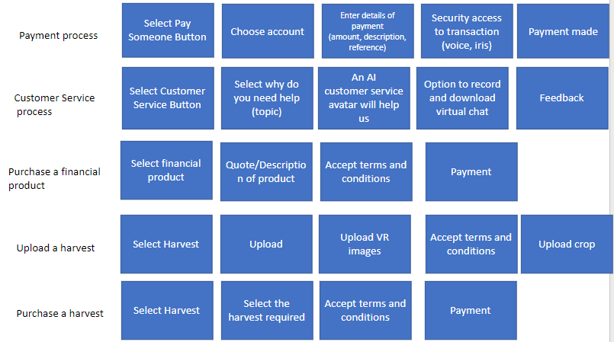

PRODUCTS

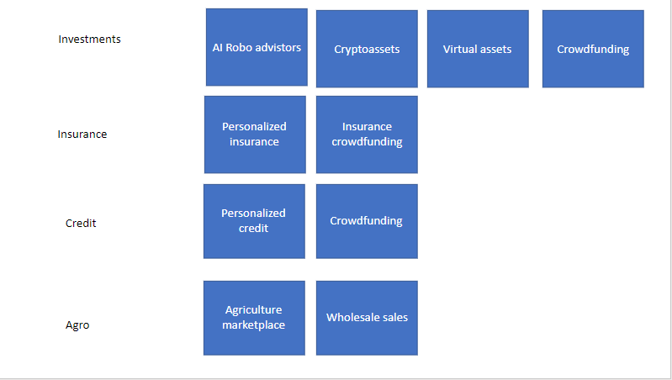

PLATFORMS

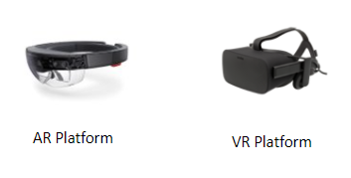

MOCKUPS

LOGIN

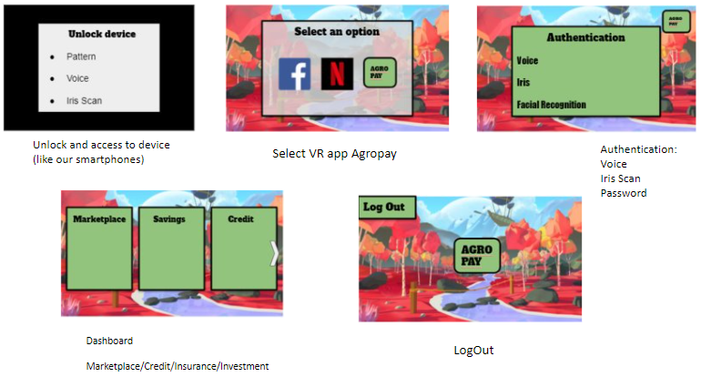

MARKETPLACE TRANSACTION

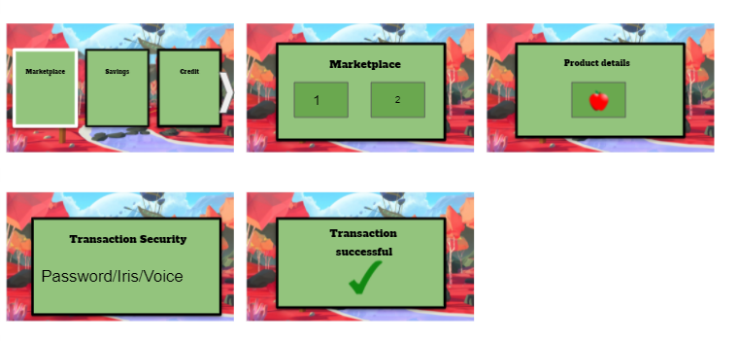

UPLOAD PRODUCTS

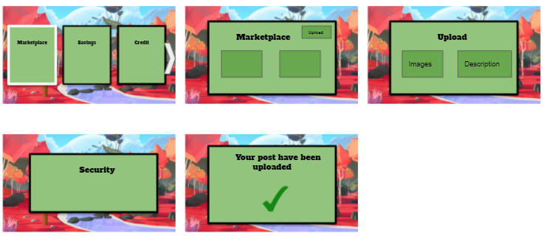

PAY SOMEONE TRANSACTION

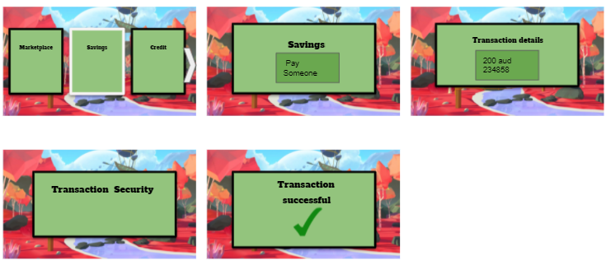

INSURANCE

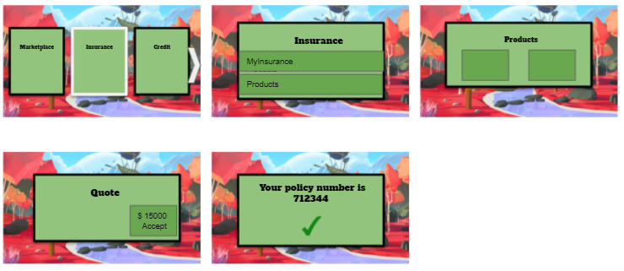

CUSTOMER SERVICE DESK VIRTUAL

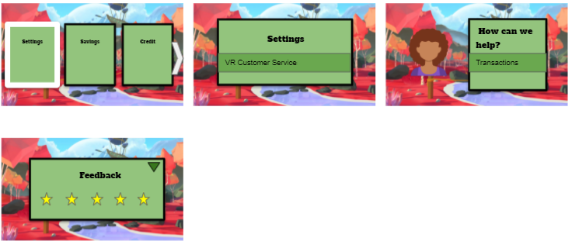

## Security Considerations

When it comes to discussing the security considerations, it can be said that the first and foremost security consideration is the data security of information stored in the database of the system. However, there will be both the financial data like the credit and debit information as well as the personal data like the personal profile of the farmers and the clients will be stored and the database. On the other hand, there is a high possibility of data breach and loss of financial and personal data if the data are not safeguarded using the appropriate security measures. Therefore, antivirus software should be installed in all the systems with installing firewalls to protect the data from viruses, worms and other cyber threats (Gas, 2017). Then again, these software applications should be updated on regular basis to make them work properly. Furthermore, the policies like a strong password policy, acceptable use policy and authorised data access policy must be put in place in order to intensify the data security. Then again, the farmers and the other stakeholders should be provided with enough understanding about the use of the security policies and tools so that they can apply them efficiently to ensure the security of their individual data stored in the system database (van Klyton, Tavera-Mesias & Castaño-Muñoz, 2021).

## Ethical Considerations

The Ethical considerations for this App would be embedded in the App. It does not allow any movement that would not considered ethical for the society. Technological ethical considerations that are defined by the Colombian authorities or globally will be automatically updated to the App ethical manual through artificial intelligence and anyone would be allowed to brake them.

As the App own ethical consideration can be taken into count the followings, all the App designs and source code used to create or improve the App would be reviewed by a number of people to secure that it is not incurring in wrong ethical considerations. All the people involved in the development of the project must follow the Code of Ethics and Professional Practice of Software Engineering that states the principles that the software professional must follow, which defend mainly the society, the product, the client, and the staff (Gotterbarn, Miller, and Rogerson, 1997).

## Solution Evaluation

According to the functional requirements defined in the stakeholder requirements document, the App designed is meeting the client need that the system be compatible with all technological platforms of 2050. Additionally, it has a secure login with double authentication process. The use of authentication with biometric data such as facial, fingerprints or voice recognition are optional as specified. A contact lists will be kept to streamline payment management. Transfers will be backed by block chain technology.

Regarding credits, the status of each credit and information will be shown. Additionally, credit payments can be customizable. Payment reminder will be sent 3 days before the deadline (configurable). Moreover, the insurance feature allows payments through the accounts. Policies visualization are available in system. Claims and doubts can be done via chatbot.

Furthermore, the creation and implementation of a real-time currency exchange can be done by the system. A currency calculator will be also available, as well as the option to transfer money in different currencies to accounts other than ours.

Finally, the Investment section has the option to establish a recurring investment. It will generate monthly investment reports. It will shows an investment instrument finder. Basic financial data for each employee will appear, and general and individual statistics of each employee account.

## Conclusion

At the end of this report, it is concluded that it is essential to focus upon or address the new challenges that the farmers in the rural and urban areas are possibly going to come across since it is analysed that the farmers in the country end up playing the role of a potential building block in the economic system and hence helping them get accustomed to the new system through offering them with the relevant services and products would be critical to holding the balance in the economic system of the country. Additionally, monthly investment should be done with allocating funds for different project activities following which the monthly investment should be documented properly to allocate funds effectively for the next month. Apart from that, the mentioned security measures must be applied to safeguard the personal and financial information stored in the database of the system. Be that as it may, in this project, the design thinking approach would be most suitable to resolve the incompatibility issue between the farmers and the cashless design. In addition to that the essential aspects associated with the design thinking approach are inspiration, implementation and ideation. However, the farmers are needed to be inspired to upgrade themselves through accepting the changes and by engaging themselves in this journey.

# Appendices

### 10.1 The data collection strategy

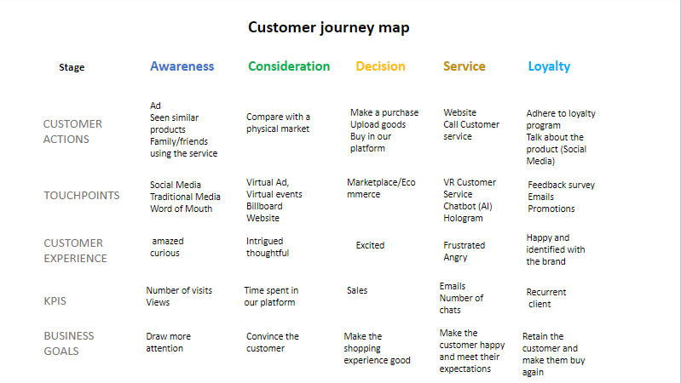

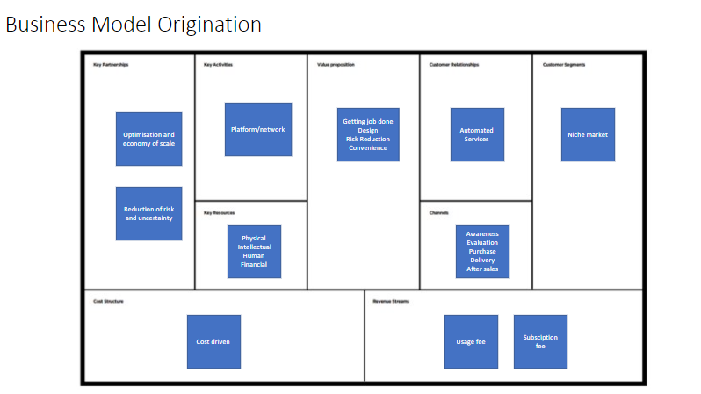

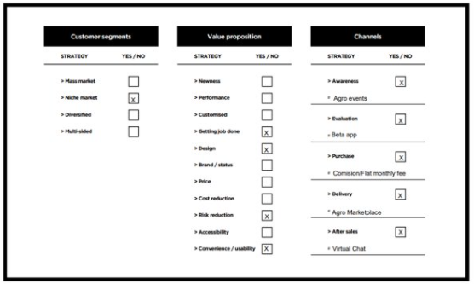 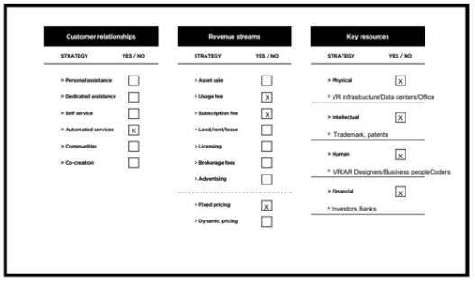

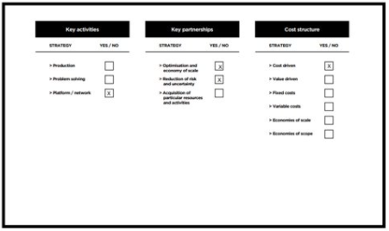

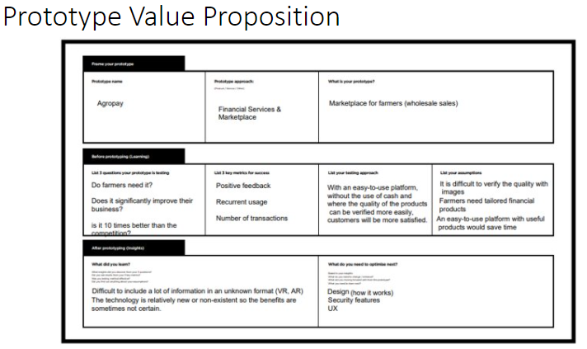

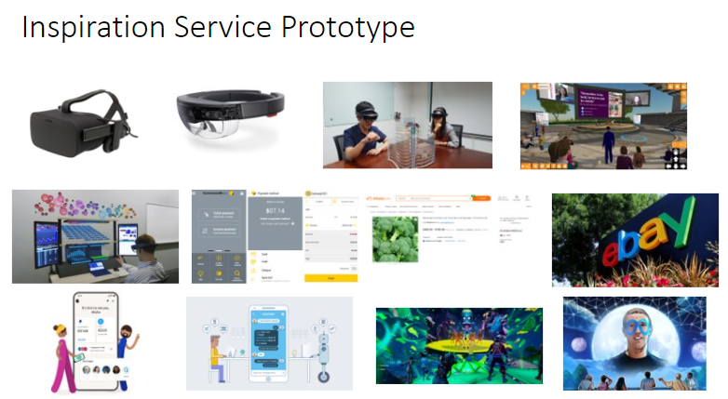

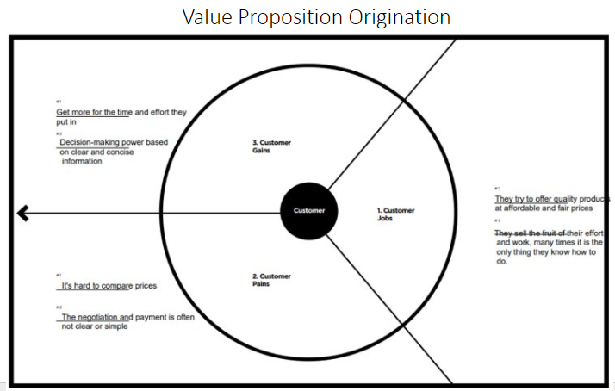

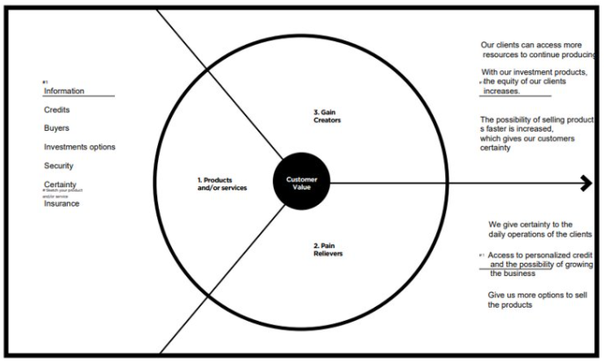

BUSINESS MODEL CANVAS

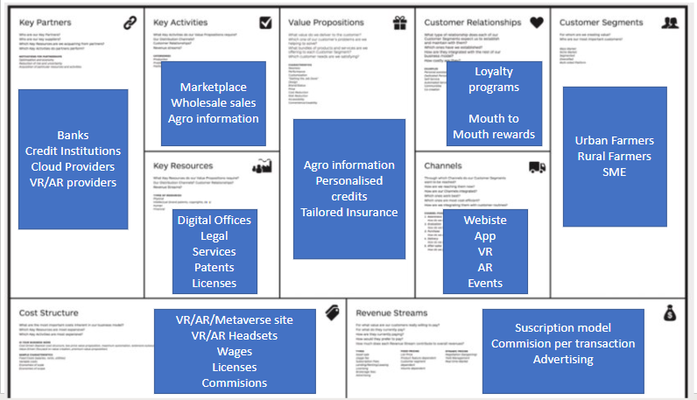

ASSESSMENT 1

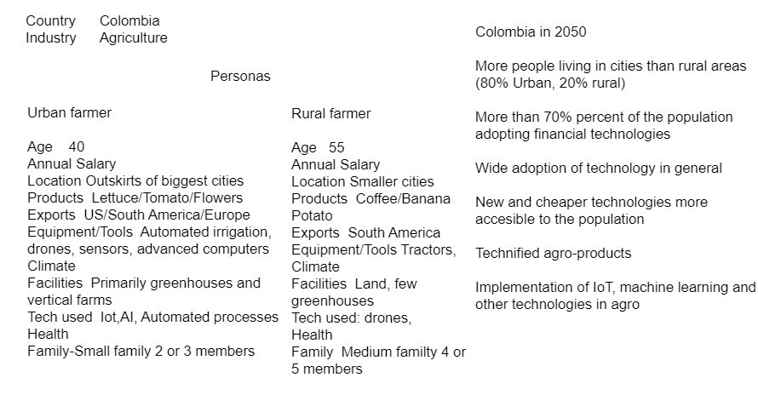

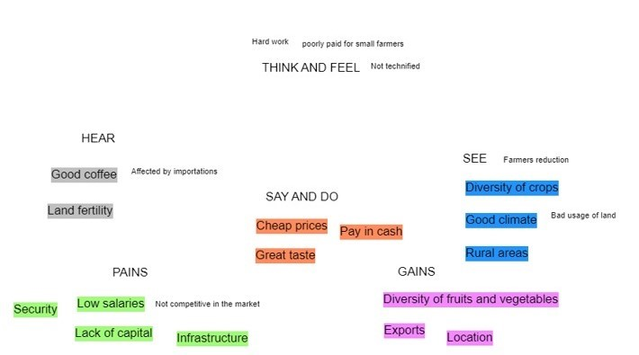

DATA

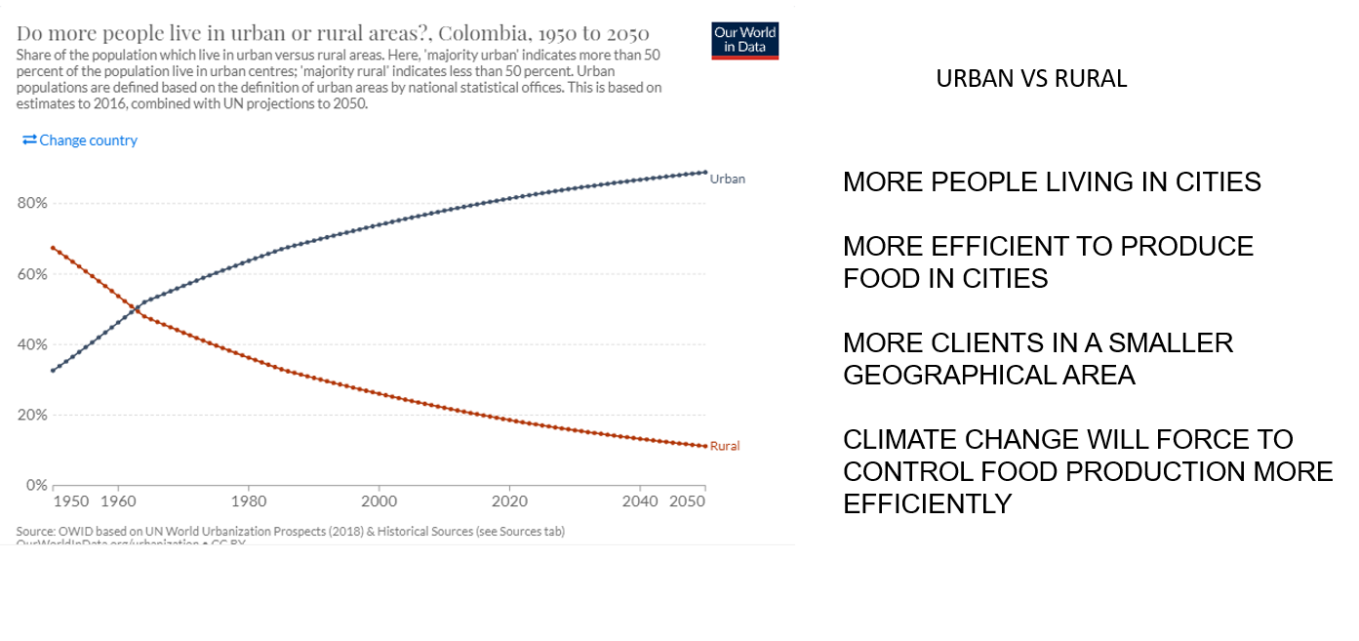

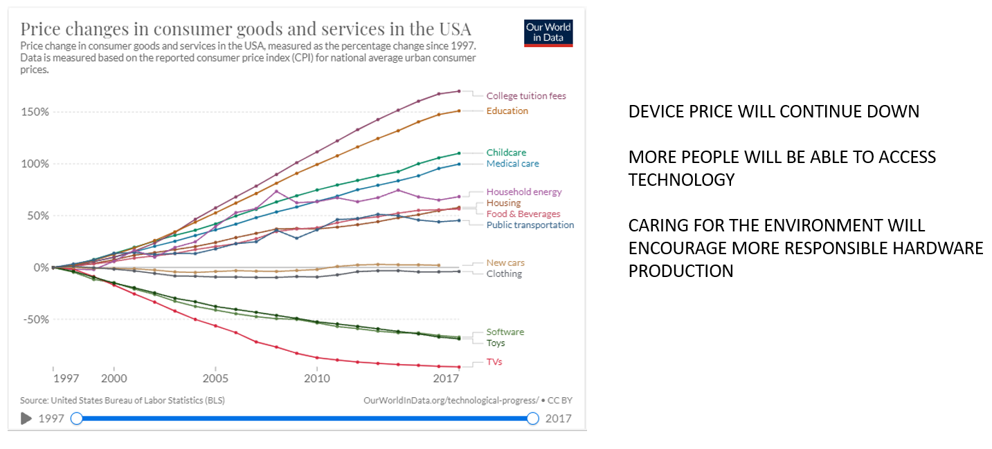

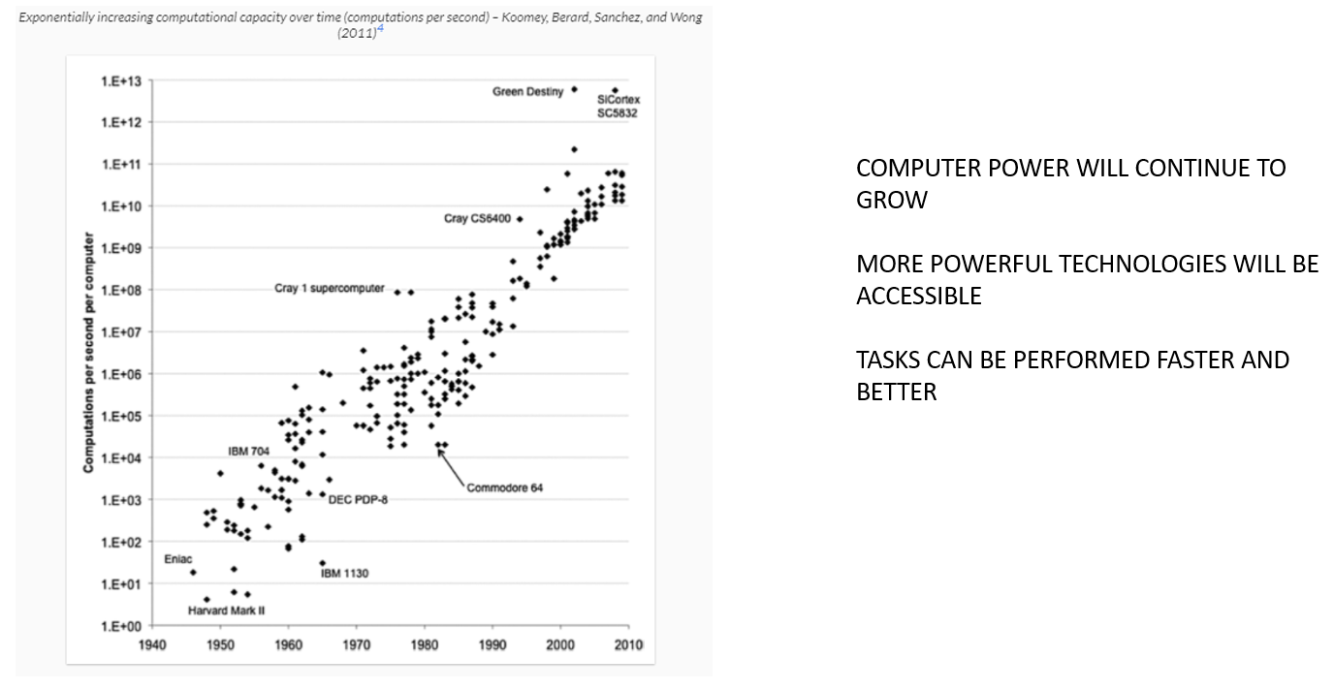

## References according to the APA style

Defourny, J., Nyssens, M., and Brolis, O. (2020). Testing Social Enterprise Models Across the World: Evidence From the “International Comparative Social Enterprise Models (ICSEM) Project”. *Nonprofit And Voluntary Sector Quarterly*, *50*(2), 420-440. https://doi.org/10.1177/0899764020959470

Gotterbarn, D., Miller, K., and Rogerson, S. 1997. Software engineering code of ethics. Commun. ACM 40, 11 (November 1997), 110-118. DOI: 10.1145/265684.265699

Gas, S. (2017). Mobile Money, Cashless Society and Financial Inclusion: Case Study on Somalia and Kenya. *SSRN Electronic Journal*. https://doi.org/10.2139/ssrn.3348257

Plano, C., Behrens, R., and Zuidgeest, M. (2020). Towards evening paratransit services to complement scheduled public transport in Cape Town: A driver attitudinal survey of alternative policy interventions. *Transportation Research Part A: Policy And Practice*, *132*, 273-289. https://doi.org/10.1016/j.tra.2019.11.015

Sperling, L., Louwaars, N., de Ponti, O., Smale, M., Baributsa, D., and van Etten, J. (2020). Viewpoint: COVID-19 and seed security response now and beyond. *Food Policy*, *97*, 102000. https://doi.org/10.1016/j.foodpol.2020.102000

van Klyton, A., Tavera-Mesias, J., and Castaño-Muñoz, W. (2021). Value co-creation and co-destruction in the first cashless society in Colombia – a middle-range theory approach. *Information Technology & People*, *ahead-of-print*(ahead-of-print). https://doi.org/10.1108/itp-05-2020-0273

van Klyton, A., Tavera-Mesías, J., and Castaño-Muñoz, W. (2021). Innovation resistance and mobile banking in rural Colombia. *Journal Of Rural Studies*, *81*, 269-280. <https://doi.org/10.1016/j.jrurstud.2020.10.035>

Law, E. L. C., Roto, V., Hassenzahl, M., Vermeeren, A. P., & Kort, J. (2009, April). Understanding, scoping and defining user experience: a survey approach. In *Proceedings of the SIGCHI conference on human factors in computing systems* (pp. 719-728).

***IMPORTANT NOTES:***

*Save drafts and sources used to prepare this assessment* *as well as your notes and any sources you used to draw on in preparing it*

*Please submit ONE WORD DOCUMENT (.doc or .docx) via the MIS611 Assessment 2 Section found in the Main navigation menu of the MIS611 Blackboard Site.*

*This Assessment should be 4000 words (+/-10%)*

*The Cover Page, Academic Integrity Declaration and References are not included in the word count.*

*Save file with the correct naming convention: subject code_ M#_ surname_ first name initial_ assessment title: e.g. MIS611_M2_Jones_S_Research Report*

*Extensions will be considered only in extenuating circumstances where the student/s has*

*applied before the due date. At that point, students are required to provide the latest draft,*

*in case the extension is not granted.*

*Students are responsible for keeping appropriate back-ups and drafts of their assessments*

*and to submit the correct version. Torrens University Australia policies apply to the*

*preparation and submission of this assignment.*

*Learning Facilitators will provide feedback via the Grade Centre in the LMS portal. Feedback can be viewed in My Grades.*